VE311 Lab 1

Weikai Zhou 518021911039

1. **Voltage Regulator**
2. In this part, we first build the circuit below (Figure 1) in Proteus, where $R_{1}=5 kΩ$,

$V_{s}=10 V$. The simulation result is also in the figure.

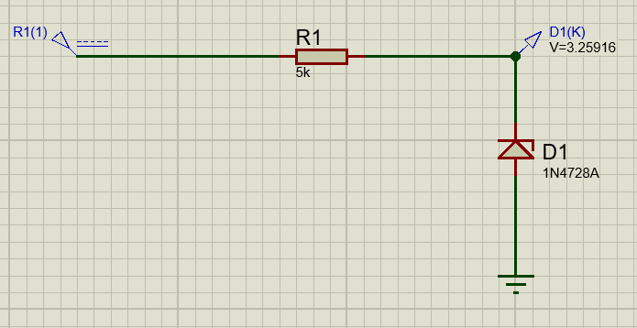Figure 1. Proteus circuit and simulation result

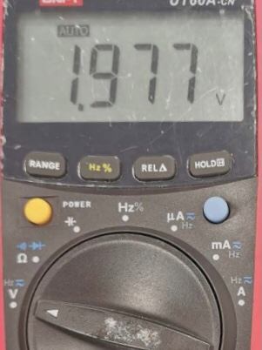When doing the lab, the measurement result is shown below (Figure 2).

Figure 2. Measurement

From the figure, we know the measurement result is 1.977 V, but the diode we used is different from manual. Considering the diode in manual, the typical $V_{z}=10Ω$, and theoretically, the voltage should be

$$\frac{\left(10-3.3\right)×30}{30+5000}+3.3=3.340 V,$$

and our simulation result is close to this value.

1. In this part, we first build the circuit below (Figure 3) in Proteus, where $R_{1}=5 kΩ$**,**

$V_{s}=10+1\sin\left(2π60∙time\right) V$. The simulation result is in Figure 4.

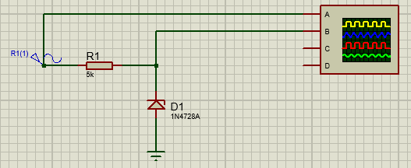Figure 3. Proteus circuit

Figure 4. Simu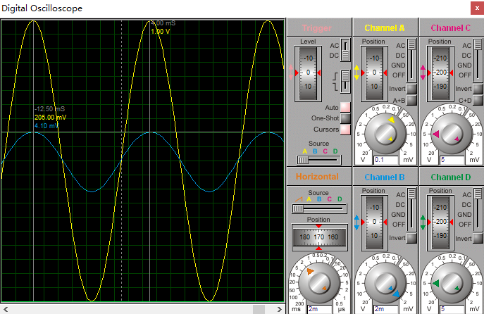lation result

From the cursors of the simulation result, we can have that the line regulation is

$$\frac{4.1×{10}^{-3}}{1.00}=4.1×{10}^{-3}.$$

By using the equation that

$$line regulation=\frac{R_{z}}{R+R_{z}},$$

we can get that $R_{z}=20.58 Ω$.

In lab, we get the following waveform (Figure 5), which is similar to the simulation waveform.

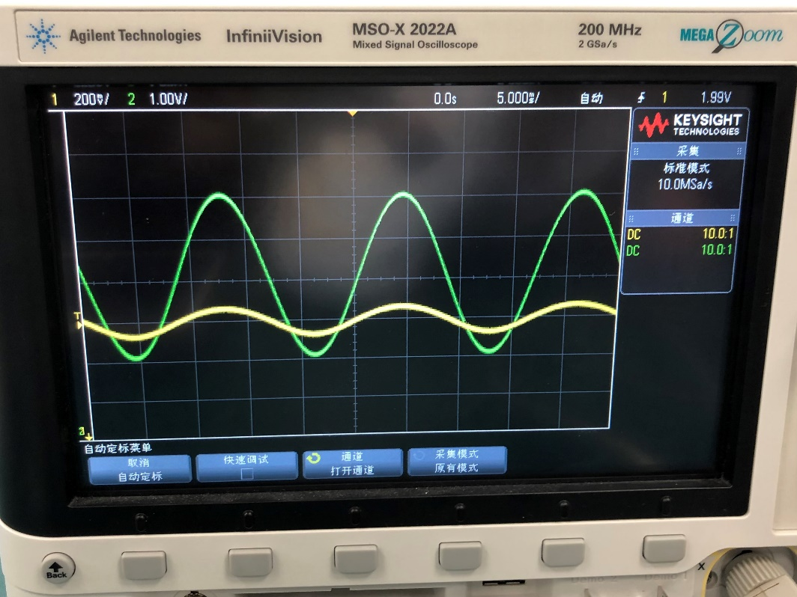Figure 5. Waveform

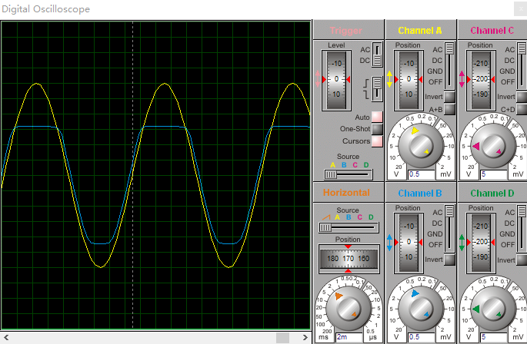If $V_{s}=2+3\sin\left(2π60∙time\right) V$, we will get the following result (Figure 6).

Figure 6. Simulation result

When the voltage is higher than $V_{z}$, the $V_{L}$ is almost the same as $V_{z}$. When the voltage is lower than $V_{z}$, the $V_{L}$ is the same as $V_{s}$.

1. In this part, we first build the circuit below (Figure 7) in Proteus, where $R_{1}=5 kΩ$,

$V_{s}=10 V$.

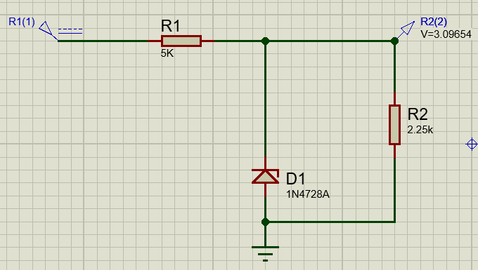Figure 7. Simulation result

From the figure, we can know that $R_{L, min}=2.25 kΩ$. If we continue decrease $R_{L}$, the voltage regulator stops working.

In lab, we get the following result (Figure 8).

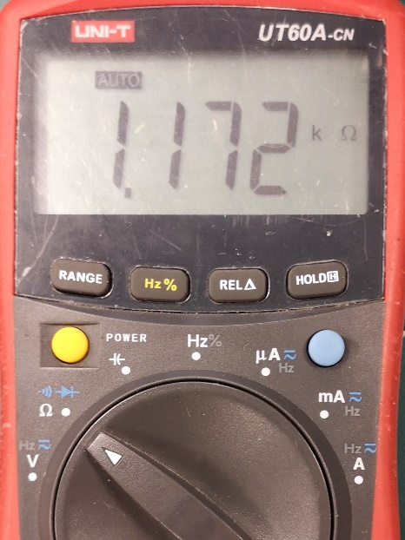Figure 8. Lab result

If we want to make $R_{L, min}$ becomes 10 times smaller, we can decrease $R$ to be 10 times smaller.

1. **Half-Wave Rectifier**

In this part, we first using the following equation to get the value of *C*.

$$V_{r}=\left(V_{s}-V_{on}\right)\frac{T}{RC}<0.1 => C=3.67×{10}^{-5} F.$$

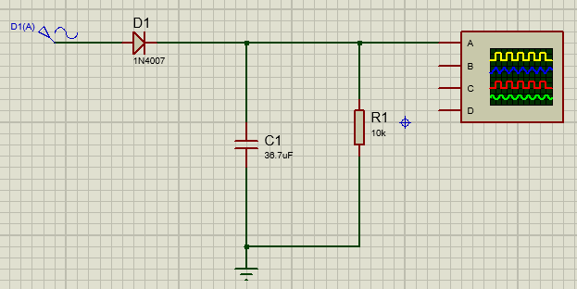Then, we can get the following Proteus circuit (Figure 9).

Figure 9. Proteus circuit

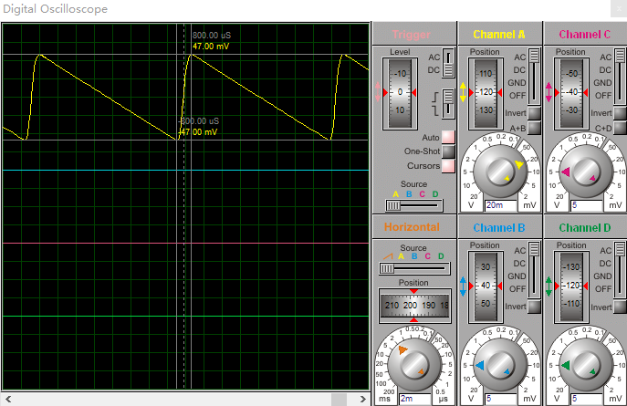And we can get the following simulation result (Figure 10).

Figure 10. Simulation result

We can check that $V_{r}=0.094 V$, satisfying our goal.

Besides, we can have the following

$$V_{dc}=V_{s}-V_{on}=3-0.8=2.2 V$$

$$I_{dc}=\frac{V_{dc}}{R}=\frac{2.2}{10 k}=2.2×{10}^{-4} A$$

$$θ_{c}=\sqrt{\frac{2V_{r}}{V_{s}}}=\sqrt{\frac{2×0.1}{3}}=0.258 rad$$

$$ΔT=\frac{1}{ω}\sqrt{\frac{2V_{r}}{V_{s}}}=\frac{1}{2π60}\sqrt{\frac{2×0.1}{3}}=6.85×{10}^{-4} s$$

$$I_{peak}=\frac{2I_{dc}T}{ΔT}=\frac{2×2.2×{10}^{-4}×\frac{1}{60}}{6.85×{10}^{-4}}=0.0107 A$$

$$I_{surge}=ωCV_{s}=2π60×3.67×{10}^{-5}×3=0.0415 A$$

$$PIV=2V_{s}-V_{on}=2×3-0.8=5.2 V$$

If $V_{s}=3\sin\left(2π30∙time\right)$, we can know that $V_{r}$ may become 2 times of the original value from the equation $V_{r}=\left(V_{s}-V_{on}\right)\frac{T}{RC}$.

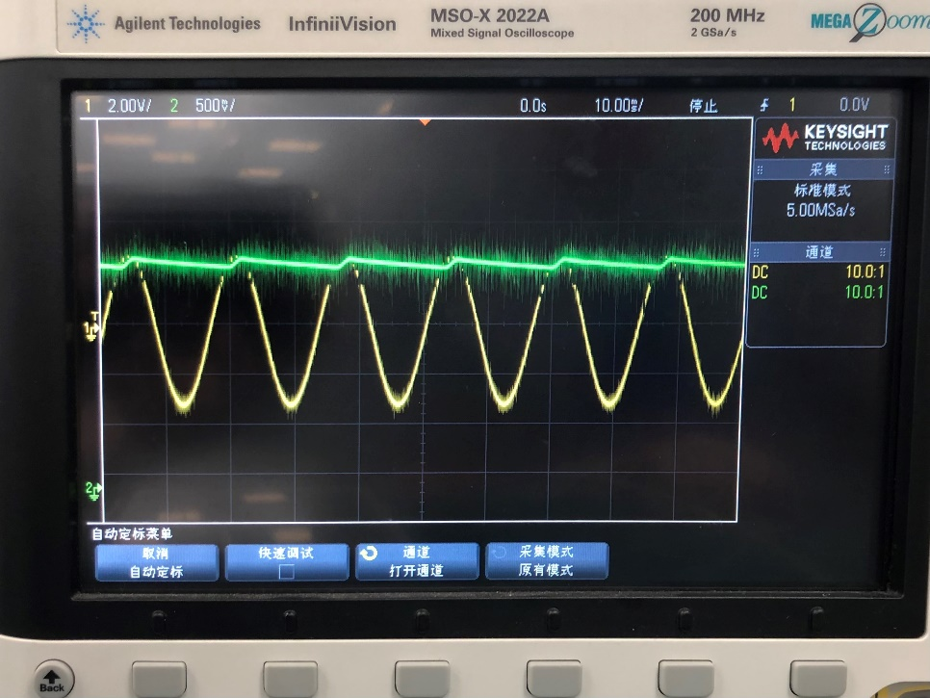 In lab, we have the following wave form (Figure 11).

Figure 11. Wave form